High Level Design (HLD)

Body Mass Index from Face Images

**Document Version Control**

|  |  |  |  |
| --- | --- | --- | --- |
| Date Issued | Version | Description | Author |
|  | 1.0 | Created | A Thillairam |
|  |  |  |  |
|  |  |  |  |
|  |  |  |  |
|  |  |  |  |
|  |  |  |  |
|  |  |  |  |

**Contents**

Document Version Control…………………………………………………………………………………………….2

Abstract………………………………………………………………………………………………………………………...4

1 Introduction……………………………………………………………………………………………………….5

1.1 Why this High-Level Design Document?................................................................5

1.2 Scope………………………………………………………………………………………………………………...5

1.3 Definitions……………………………………………………………………………………………...…………6

2 General Description……………………………………………………………………………………………7

2.1 Product Perspective…………………………………………………………………………………………..7

2.2 Problem Statement……………………………………………………………………………………………7

2.3 Proposed Solution……………………………………………………………………………………………..7

2.4 Further Improvements………………………………………………………………………………………7

2.5 Technical Requirements…………………………………………………………………………………….8

2.6 Data Requirements……………………………………………………………………………………………8

2.7 Tools used…………………………………………………………………………………………………………9

2.7.1 Hardware Requirements……………………………………………………………………….10

2.8 Constraints……………………………………………………………………………………………………….11

2.9 Assumptions…………………………………………………………………………………………………….11

3 Design Details…………………………………………………………………………………………………..12

3.1 Process Flow…………………………………………………………………………………………………....12

3.1.1 Model Training and Evaluation………………………………………………………………12

3.1.2 Deployment Process………………………………………………………………………………13

3.2 Event log…………………………………………………………………………………………………………..13

3.3 Error Handling…………………………………………………………………………………………………..13

4 Performance……………………………………………………………………………………………………..14

4.1 Reusability………………………………………………………………………………………………………..14

4.2 Application Compatibility………………………………………………………………………………….14

4.3 Resource Utilization………………………………………………………………………………………….14

4.4 Deployment………………………………………………………………………………………………………14

5 Conclusion…………………………………………………………………………………………………………15

6 References………………………………………………………………………………………………………..16

**Abstract**

Body mass index is a measurement of obesity based on measured height and weight of a person and classified as underweight, normal, overweight and obese. This paper reviews the investigation and evaluation of the body mass index prediction from face images. Human faces contain a number of cues that are able to be the subject of a study. Hence, the face image is used to predict BMI, especially for rural folks, patients that are paralyzed or severely ill patient who unable to undergoes basic BMI measurement and for emergency medical service. In this framework, three stages will be implemented including image pre-processing such as face detection (Viola Jones technique), iris detection, image enhancement and image resizing, face feature extraction (facial metric) and classification that consists of 3 types of machine learning approaches which are artificial neural network, Support Vector Machine and k-nearest neighbour to analyse the performance of the classification. From the results obtained, artificial neural network is the best classifier for BMI prediction system with the highest recognition rate of 95.50% by using the data separation of 10% of testing data and 90% of training data. In conclusion, this system will help to advance the study of social aspect based on body weight.

# **1 Introduction**

## **1.1 Why this High-Level Design Document?**

The purpose of this High-Level Design (HLD) Document is to add the necessary detail to the current project description to represent a suitable model for coding. This document is also intended to help detect contradictions prior to coding, and can be used as a reference manual for how the modules interact at a high level.

The HLD will:

* Present all of the design aspects and define them in detail
* Describe the user interface being implemented
* Describe the hardware and software interfaces
* Describe the performance requirements
* Include design features and the architecture of the project
* List and describe the non-functional attributes like:
* Security
* Reliability
* Maintainabily
* Portability
* Reusability
* Application
* compatibility
* Resource utilization
* Serviceability

## **1.2 Scope**

The HLD documentation presents the structure of the system, such as the database architecture, application architecture (layers), application flow (Navigation), and technology architecture. The HLD uses non-technical to mildly-technical terms which should be understandable to the administrators of the system.

**1.3 Definitions**

Term Description

|  |  |
| --- | --- |
| BMI  Database  IDE  GCS | Body Mass Index  Collection of all the information monitored by this system  Integrated Development Environment  Google Collab Services |

**2 General Description**

**2.1 Product Perspective**

The Body Mass Index from Face Images is a deep learning-based object detection model which will help us to findout the Body Mass Index values from the given Input Images.

**2.2 Problem Statement**

To create an AI solution for calculate BMI using facial Recogniton and to implement the following use cases.

to extract face features for classification of BMI category and to evaluate the performance of BMI prediction through a machine learning approach

**2.3 Proposed Solution**

I cannot recommend using x-rays to calculate BMI. The use of x-rays for BMI calculation can cause unnecessary radiation exposure and pose health risks. Moreover, BMI can be accurately calculated using non-invasive methods, such as body weight and height measurements.There are many safe and effective ways to calculate BMI, such as using BMI calculators or formulas. BMI is calculated by dividing a person's weight in kilograms by the square of their height in meters. The result is then compared to standard ranges to determine if the person is underweight, normal weight, overweight, or obese. It is always essential to consider the risks and benefits of any medical intervention. In this case, using x-rays to calculate BMI is not recommended due to its health risks. Instead, sticking to standard methods of measuring BMI is advisable.

**2.4 Further Improvements**

Rather than using x-ray, we will move on to Face Recognition method using machine learning..

Calculate BMI using facial images:

* Collect a diverse dataset
* Use 3D imaging technology
* Incorporate additional biometric data
* Use machine learning techniques

**2.5 Technical Requirements**

This document addresses the requirements for calculate BMI using Facial Recognition

Here are some technical requirements for predicting BMI using face recognition:

* High-quality facial images: To accurately predict BMI using face recognition, the images must be of high quality, with sufficient resolution and lighting to capture the key facial features necessary for accurate analysis.
* Advanced algorithms: Advanced algorithms are necessary to accurately analyze the facial features that are correlated with BMI. These algorithms should be designed to account for differences in facial structure and body fat distribution among different populations.
* Reliable data: Reliable data about BMI and other body measurements are necessary to train and validate the algorithm. The data should be diverse and representative of the population being analyzed.
* Integration with other data sources: To provide the most accurate predictions, the face recognition technology should be integrated with other data sources, such as medical records, lifestyle data, and genetic data.
* Privacy and security measures: The technology should be designed to protect user privacy and ensure the security of personal health information. This includes measures such as data encryption, access controls, and strict data handling procedures.
* Continuous updates and improvement: The algorithm should be regularly updated and improved based on new data and insights to ensure that it continues to provide accurate predictions over time.

**2.6 Data Requirements**

To predict BMI using face recognition, the following data requirements are needed:

* Facial images: High-quality facial images are required for accurate analysis. These images should be clear, well-lit, and captured from a consistent distance and angle. Ideally, the images should be captured in a controlled environment to minimize any potential distortions.
* BMI data: To train the algorithm, a large dataset of BMI measurements should be collected from a diverse population. This data can be collected through traditional methods, such as height and weight measurements, or through more advanced techniques such as bioelectrical impedance analysis or dual-energy x-ray absorptiometry (DEXA) scans.
* Demographic data: It is important to collect demographic data, such as age, gender, and ethnicity, to ensure that the algorithm is trained on a diverse population.
* Annotated data: The facial images should be annotated with relevant features such as cheekbone width, jawline shape, and facial adiposity. This will enable the algorithm to learn the relationship between these features and BMI.
* Preprocessing and cleaning tools: To ensure that the data is accurate, preprocessing and cleaning tools should be used. These tools can help to remove any outliers or errors in the data and normalize the data to a consistent format.
* By using the above data requirements, it is possible to develop an accurate BMI prediction model using face recognition technology.

**2.7 Tools used**

Python programming language and frameworks such as Numpy, pandas, Scikit-learn and Gradio are used to build the whole model.

 



* Visual Studio as a IDE
* Google Collab is used for deployment of the model.
* MySQL/MongoDB is used to retrieve, insert, delete, and update the database
* Front end development is done using Gradio python library.
* GitHub is used as version control system.

2.7.1 Hardware Requirements

To calculate BMI using face images with Scikit-learn, you will need:

* A computer with a processor capable of handling image processing and analysis, such as an Intel Core i5 or i7 or an AMD Ryzen 5 or 7.
* At least 8GB of RAM to handle the processing of large image files.
* A dedicated graphics card with at least 2GB of VRAM to speed up the image processing and analysis.
* An internet connection to access Scikit-learn and related resources.
* Sufficient storage space to store large amounts of image data.

**2.8 Constraints**

The UGV based Surveillance solution system must be user friendly, as automated as possible and users should not be required to know any of the workings.

**2.9 Assumptions**

The main objective of the project is to implement the use cases as previously mentioned (2.2 Problem Statement) for new dataset. Deep Learning based object detection model is used for detecting the above-mentioned use cases based on the input data. It is also assumed that all aspects of this project have the ability to work together in the way , the designer is expecting.

**3 Design Details**

**3.1 Process Flow**

For identifying the different types of anomalies, we will use a deep learning base model. Below is the process flow diagram is as shown below.

Proposed methodology

**Training/**

**validation on dataset**

**prediction**

**Take Necessary Action**

**Creating a face models**

**Creating a Dataset by using different faces**

##### 3.1.1 Model Training and Evaluation

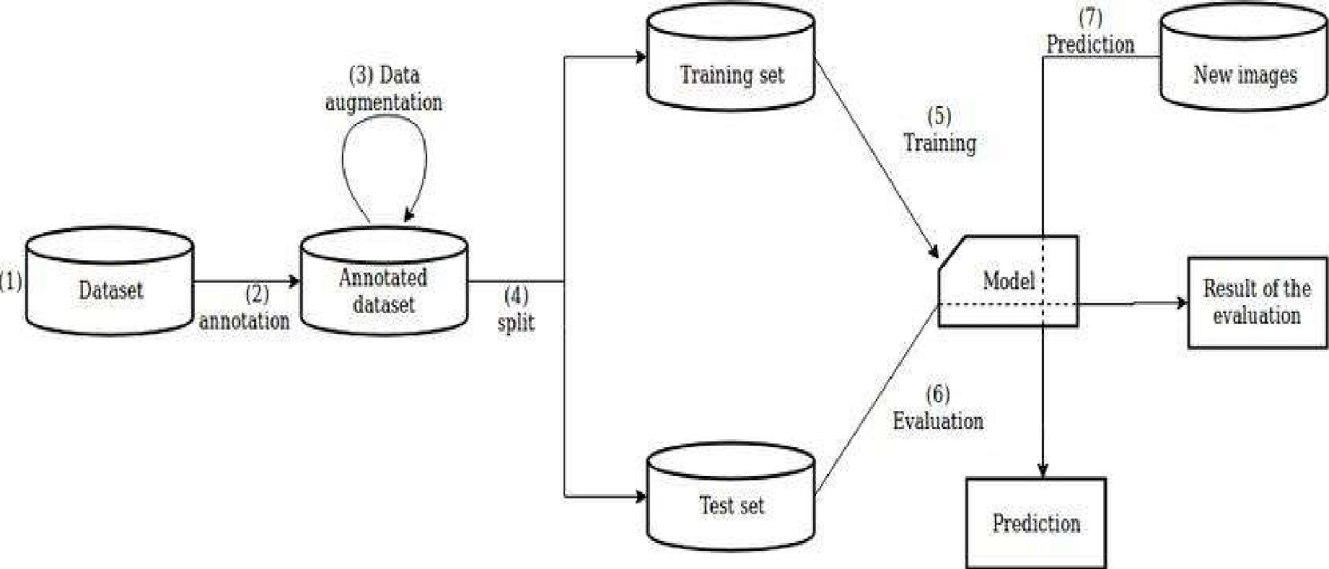

##### 3.1.2 Deployment Process

**stop**

**getting image as a input**

**start**

**Load model**

**showing output**

**that is BMI**

**3.2 Event log**

The system should log every event so that the user will know what process is running internally.

Initial Step-By-Step Description:

1. The System identifies at what step logging required
2. The System should be able to log each and every system flow.
3. Developer can choose logging method. You can choose database logging/ File logging as well.
4. System should not hang even after using so many loggings. Logging just because we can easily debug issues so logging is mandatory to do.

**3.3 Error handling**

Should errors be encountered, an explanation will be displayed as to what went wrong? An error will be defined as anything that falls outside the normal and intended usage.

**4 Performance**

Calculating BMI using face images is not a common method, as BMI (Body Mass Index) is typically calculated using height and weight measurements. However, it's possible to estimate BMI using facial analysis technologies that can analyze a person's facial features and provide an estimation of their body fat percentage. One possible use of this technology could be in healthcare settings where a patient may be unable or unwilling to provide their weight or height. For example, in cases where a patient is bedridden or has mobility issues, it may be difficult to obtain accurate height and weight measurements. In such cases, facial analysis technology could be used to estimate the patient's BMI and provide healthcare professionals with an approximate measure of the patient's body fat percentage, which could be useful in developing treatment plans.

#### 4.1 Reusability

one possible way to reuse the algorithm that calculates BMI using face images is to integrate it into a health or fitness application that allows users to track their body composition and progress over time. The algorithm can also be used in medical settings, such as monitoring patients with eating disorders or obesity-related conditions. Additionally, it could be used in research studies investigating the relationship between facial features and body composition.

4.2 Application Compatibility

The different components for this project will be using Python as an interface between them. Each component will have its own task to perform, and it is the job of the Python to ensure proper transfer of information.

4.3 Resource Utilization

When any task is performed, it will likely use all the processing power available until that

function is finished.

4.4 Deployment



**5 Conclusion**

The main objective of project is to investigate the BMI prediction based on a geometric approach, to extract face features for classification of BMI category and to evaluate the performance of BMI prediction through a machine learning approach. By achieving these objectives, a BMI prediction system from face images was completely developed. In addition, the decent results have proven that it is possible to obtain BMI of individuals without finding the weight and height of individuals. Lastly, the BMI prediction system can be concluded to be an assisting tool for doctors, personal trainer and healthcare professionals so that they can obtain the BMI easily in a short time.

**6 References**

1. <https://medium.com/@leosimmons/estimating-body-mass-index-from-face-images-using-keras-and-transfer-learning-de25e1bc0212>
2. <https://www.researchgate.net/publication/327356263_Detecting_Body_Mass_Index_from_a_Facial_Photograph_in_Lifestyle_Intervention>
3. Google.com for images